**Review Worksheet Answers – Fossil evidence for evolution – dendrochronology, stratigraphy**

1: What types of materials can be aged using radiocarbon dating?

(3 marks)

*Carbon-based materials (1), less than 50 000 years old (1). Examples include: fire ash, wood, bone and tissue remains of organisms. (1)*

2: What types of materials can be aged using potassium-argon dating?

(2 marks)

*Certain types of rock (1) greater than 200 000 years old (1).*

3: What is dendrochronology? Is it a form of absolute dating, or relative dating?

(3 marks)

*Dendrochronology is the study of tree rings (1) to determine the age of a sample of wood (1). It is a form of absolute dating (1).*

4: What is required to be able to date an ancient sample using dendrochronology?

(4 marks)

*A succession of local timber (1) where ages overlap (1), from the present day, back to the sample being dated (1), so that rings can be correlated and then counted (1).*

5: The following is a set of tree ring cores. A spare set of cores will be given to you on the last page in case you want to cut them out and sequence them. Look at the cores, and answer the following questions:

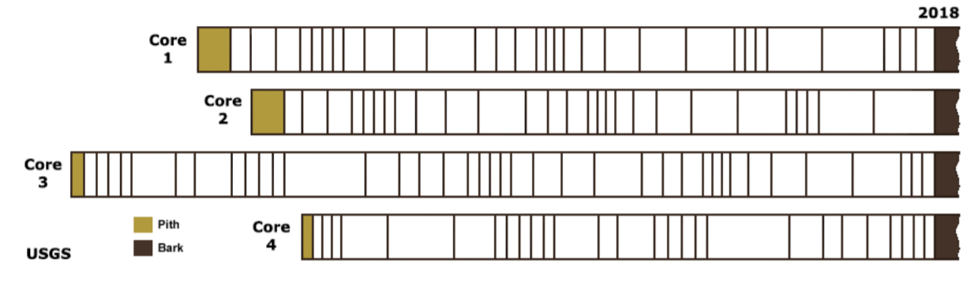

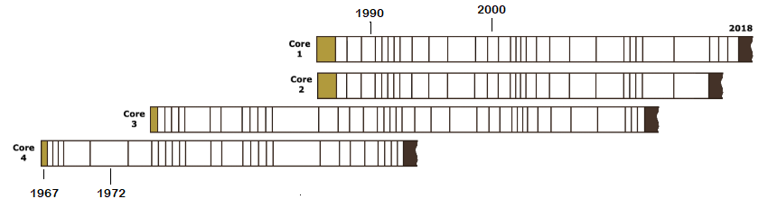

1. Which two trees started growing at the same time? (1 mark)

*The tree from Core 1 and Core 2 started growing at the same time.*

1. Which tree had lived the longest when its core was taken? (1 mark)

*The tree from Core 3.*

1. What is the earliest year represented in these tree cores? (1 mark)

*1967*

1. Jim was born in 1972. Is it likely that the rainfall was good that year? Explain your answer. (3 marks)

*Yes, the rainfall was probably good (1). The tree grew a thick ring that year (1), indicating good growing conditions (1).*

6: What is the difference between absolute dating and relative dating?

(3 marks)

*Absolute Dating provides a date in years before present (compared to the current day) (1), whereas Relative Dating allows age comparisons to be made between samples (1), without providing an exact age (1).*

7: What is stratigraphy?

(3 marks)

*Stratigraphy is the study and comparison of rock layers (1) and the fossils they contain (1), to determine relative age sequence (1).*

8: Explain what is meant by the Principle of Superposition.

(2 marks)

*The principle of superposition states that older layers are deeper in the earth (1) and younger layers are closer to the surface. (1)*

9: What is correlation of rock layers and why is it useful?

(4 marks)

*Correlation is the comparison (1) of rock layers from different locations (1), and lining up similar layer sequences (1) to provide an overall sequence of layers from oldest to youngest (1). Rocks containing similar fossils are likely to be of similar age (1).*

10: What are index fossils?

(3 marks)

*Index fossils are fossils of organisms that were widespread on Earth (1), but only existed for a short amount of time (1). If this type of fossil is in a rock layer, it can be correlated with other rock layers with the same fossil type as being the same relative age. (1)*

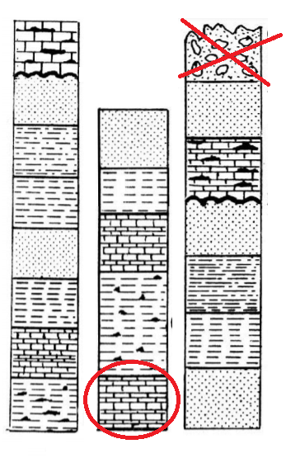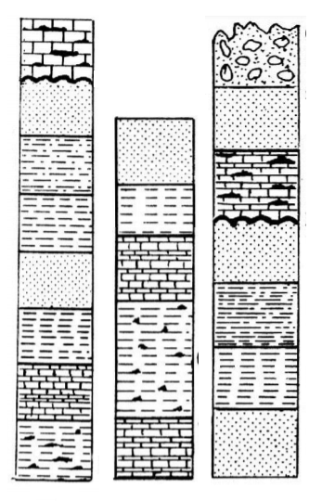

11: Shown here are three rock cores from different areas of

the world. A copy is on the last page so you can cut it

out to match it you wish.

1. Circle the oldest layer shown
2. Place a cross through the youngest layer shown.

12: The diagram below shows rock strata at a variety of locations.

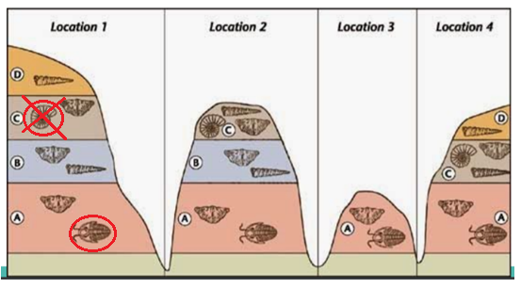

1. Circle the fossil types that could best be used as index fossils.

(1 mark)

1. Why is layer B not present in location 4?

(1 mark)

*It may be that layer B was once present but was eroded before layers C and D were deposited (1), or it may be that layer B was only deposited in some locations and not others (1).*

1. Place a cross through one example of the most recently evolved organism. Explain why you made this choice.

(4 marks)

*1 mark for correct ID of the organism. (1)*

*This organism exists in layer C, close to the surface (1). It does not exist in the older layers. All of the other specimens exist in the older layers as well as the more recent ones (1). We can infer that since it can only be seen in the younger layers, it evolved most recently. (1)*

8: Fill in the following table showing what is happening to membrane channels, ion movement and the membrane potential at each stage of an AP.

(14 marks)

|  |  |  |  |
| --- | --- | --- | --- |
|  | **Membrane channel activity** | **Ion movement** | **Membrane potential** |
| **Resting Membrane Potential (RMP)** | *Gated Na+ and K+ channels are closed. (0.5)*  *Na+/K+ pump working (0.5)* | *Na+ diffuses constantly across the membrane (0.5)*  *Na+/K+ pump uses ATP (active transport) to move 3 Na+ out of the cell and 2 K+ in, so inside is relatively negative (0.5)* | *-70 millivolts (mV) (0.5)* |
| **Depolarisation** | *Local stimulation causes some Na+ to move into the cell. (0.5)  If the threshold potential is reached: (0.5)*  *Gated Na+ channels open (0.5)* | *Na+ floods into the cell through the Na+ channels. (0.5) Inside of cell becomes relatively positive. (0.5)*  *Na+ still diffusing across and Na+/K+ pump still working but not enough to maintain RMP. (0.5)* | *Threshold: -55 mV (0.5), then rising to peak depolarisation of +30 mV (0.5)* |
| **Repolarisation** | *Membrane potential of +30mV (0.5) triggers opening of gated K+ channels (0.5)* | *K+ floods from inside of cell to outside. (0.5)*  *Inside becomes relatively more negative. (0.5)*  *Na+/K+ pump and Na+ diffusion still working but not enough to overcome other ion movement (0.5)* | *From +30mV (0.5), then falling to -70mV again. (0.5)* |
| **Hyperpolarisation** | *K+ channels stay open for a while (0.5)* | *K+ continues to move in. (0.5)*  *Na+/K+ pump and Na+ diffusion still working but not enough to overcome other ion movement. (0.5)* | *Membrane Potential falls to below -70mV (0.5)* |
| **Return to RMP** | *K+ and Na+ channels close (0.5)* | *Na+/K+ pump works to pump 3 Na+ out of the cell and 2 K+ in. (0.5) Ion distribution eventually stabilises to resting levels (0.5) with more Na+ outside, making inside relatively negative. (0.5)* | *Membrane potential climbs to*  *-70mV and stabilises. (0.5)* |